**OLS with fixed effects**

Initial model results:

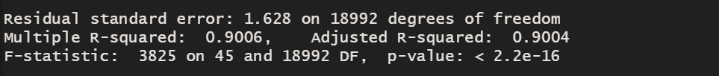

Assumption Checks:

1. Linearity

Observed vs. predicted values

Residuals vs fitted values

1. Normality of Residuals

Plot of histogram of residuals by country

Qqplot by country

Shapiro-Wilks normality test by country (p-value) (null hipothesis: normality. We reject the null hypothesis for p<0.05)

1. Homogeneity of residuals variance

Breusch-Pagan test:

p-values less than 0.05 suggest variances are significantly different and the homogeneity of variance assumption has been violated.

1. Independence of residuals error terms

Durbin Watson test

If p-value is less than 0.05, we can reject the null hypothesis and conclude that the residuals in this regression model are autocorrelated.

1. Multicollinearity

VIF

(I don’t know if its ok to do this test like this for mixed effects. Without the fixed effects these values are ok, so I don’t know if I should delete these)

Model with robust standard errors

